DPDT relay
CP029
Image:
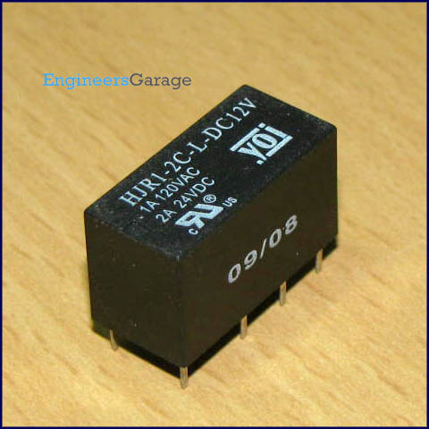
DPDT stands for double pole double throw relay. Relay is an electromagnetic device used to separate two circuits electrically and connect them magnetically. They are often used to interface an electronic circuit, which works at a low voltage to an electrical circuit which works at a high voltage. Relays are available in different configuration of operating voltages like 6V, 9V, 12V, 24V etc.

There are two sections input and output. The input section consists of a coil with two pins which are connected to the ground and the input signal. The output section consists of contactors which connect or disconnect mechanically. The output section consists of six contactors with two sets. Each set has three changeover contacts, namely, normally open (NO), normally closed (NC) and common (COM). When no supply is given the COM is connected to NC. When the operating voltage is applied the relay coil gets energized and the COM changes contact to NO.

DPDT relay can be used to power wither one device/appliance or another. While SPDT relay can only switch the output circuit between on and off states; a DPDT relay can also be used to change the polarity at the terminals of a device connected at output. For example, to drive a DC motor in both clockwise and anticlockwise directions, following connections can be done. Pins 2 & 7 can be provided with Vcc (9V for motor) and ground, respectively. The first motor terminal can be connected to pins 3 & 4 while the other terminal to pins 5 & 6. In case no input signal is given, the motor would rotate in one direction (say clockwise, depending upon the connection of its terminals). When an input signal is provided, the contactors change their positions, resulting in the anticlockwise rotation of motor.

Pin Diagram:
